US Department of Labor



Office of Job Corps

SAAS User Guide

Student Allowance  
and  
Allotment System

# General usage

## Adjust your Internet Explorer browser settings

SAAS runs on Internet Explorer 11. Take advantage of this browser's features to **adjust the size of text and the zoom level** to suit your personal preferences.

A quick way to zoom in and out is to click **CTRL –** and **CTRL +** (hold the Control key and click the minus sign or plus sign on your keyboard).

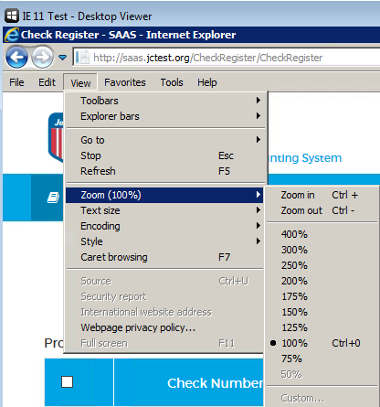

Use the tools in the upper right corner of the window to **change the window size**.

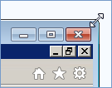

**Open multiple tabs** to use different SAAS modules at the same time. This can be especially helpful if you want to preserve a filtered view in one module while doing related work in another. For instance, you can view information on a specific Student ID in the Student Info module while performing a Data Correction on the same Student ID in the Utilities module.



## Searching efficiently



When you're searching or filtering for specific records on students, payments, checks, or other data, try these tips to optimize your results.

**Enter a unique identifier** if possible. For instance, if you're searching for a student, enter the Student ID if you have it.

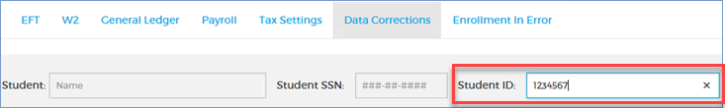

If you're filtering for a check in the Check Register, enter the Check Number if you have it.

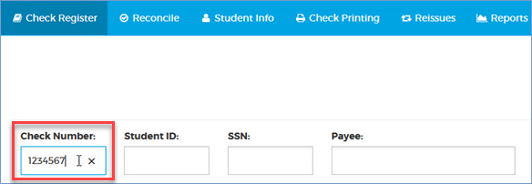

**If you don't have a unique identifier, enter as much information as possible**.

You can enter as much or as little information as you like, but the more you enter, the more precise your results will be.

In the Check Register for instance, you can enter any part of the Payee's name. The entry shown below will fetch every payee whose first or last name contains "ste." This would include such names as Stella Jones, Esteban Garcia, Anne Stevens, Jane Austen, and Jesus Beneste.

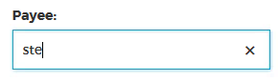

This could fetch tens of thousands of records, in which case you'll get a pop-up table like the one shown below.

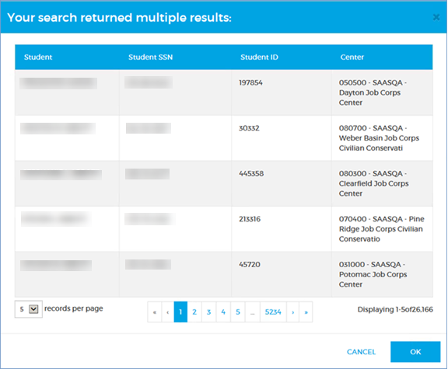

If the table contains what you consider a manageable number of results, you can select the record you want . . .

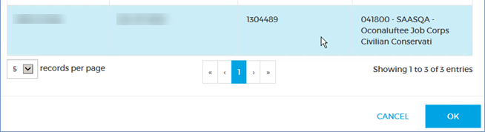

. . . and click **OK** to fetch it.

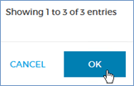

If you get an unwieldy number of results, you can **CANCEL** and try your search again.

For some fields, such as the Payee field described above, you can enter partial information. For other fields, such as Student SSN, you must enter the complete value.

## Getting through tables

SAAS tables generally behave the same way, whether they display one row or thousands of rows.

1. A drop-down at the bottom-left lets you set the number of rows per page.
2. A navigator in the center lets you click through the pages. You can get to the first and last pages by clicking the **«** and **»** buttons.
3. A counter at the bottom-right tells you how many rows are in the table and which rows you're looking at.

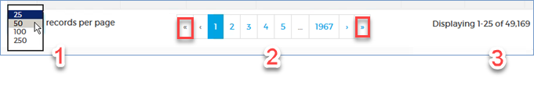

Most tables can be **sorted**. Click the arrow at the right of the column heading you want to sort on. Click it again to sort in the opposite order. If you don't see the arrow, the column can't be sorted.



**Hovering** your cursor over a column label shows a detailed description.

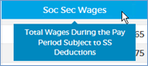

**Filters:** If a table looks strangely empty or incomplete, you might have filtered it to show fewer results. In the screenshot below, you've filtered the Check Register for "Allotment" checks.

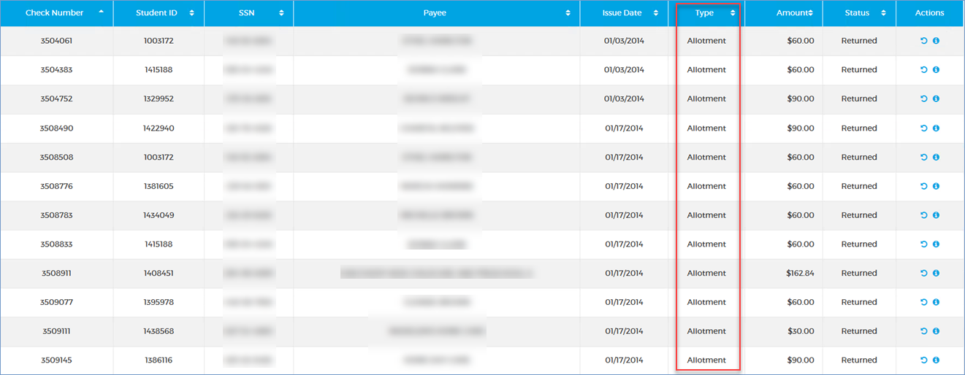

Click the **Filter** button again to see and adjust the filters. You can also clear filters by simply clicking to another module in the application.

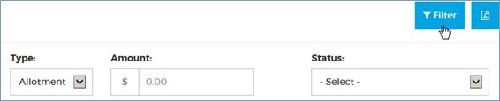

### Don't forget to scroll

Some tables have more information in them than you can see when they first load. Use the scrollbar at the side of the table to see all the rows.

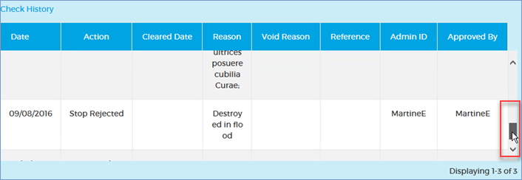

### Use the accordions

Some tables can be collapsed and expanded so you can view as much or as little information at a time as you like. Use the arrow at the side of the table to see all the rows.

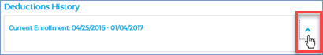

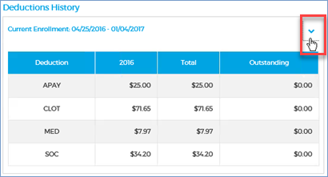

## Entering dates

You can enter dates in several ways.

**Use the datepicker.**

1. Click the datepicker at the right of any date field.



1. Click on the date you want when the calendar opens. If necessary, use the arrows at the top to browse to the month you want.

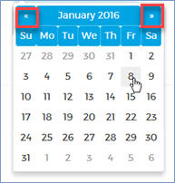

The date will be entered in the field.



## *Mandatory fields

Required fields are marked with an asterisk. You won't be able to execute a task (**SAVE** or **SUBMIT**, for instance) if you haven't filled in all the mandatory fields on a form.



To clear a *date* or anything you have *typed* in, you can use your keyboard's **Backspace** or **Delete** keys, or click the × at the far right of the field.

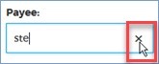

## What did I type?

Some fields let you enter up to 255 characters, but the text is entered on one line and you might wonder what you typed at the beginning. You can hover the cursor over the field to see all the text in a pop-up. To keep track of what you're entering, you can also type the text in another application like Notepad and copy/paste it in.

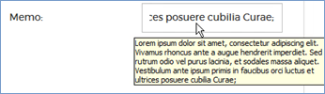

## Is it working?

**Searching for a student** may take a few seconds. If you see "Searching…" below the Search button, be patient.



**Loading big tables,** such as the Check Register, the Reissues tab, or the payroll verification tables, may also take a few seconds. If you see "Processing…" at the top-left of a table, be patient.

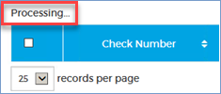

## The button doesn't do anything

If some of the dates in a **datepicker** or a button such as **SAVE, OK**, or **RECONCILE** looks grey or "won't click," you may not have completed all the information properly or you may be trying to enter invalid data. Be sure you've followed all the requirements as described. You have to enter a *complete* Student ID or SSN, or a date that falls within a specific range.

# Printing checks

## Printing check batches

Use these steps to queue check batches of all types for physical printing in EZPaySuite. You won't need paper or check stock for these steps.

1. Go to **Check Printing** 🡪 **Define Check Batch**.

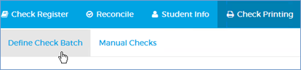

1. Complete the Define Check Batch form.

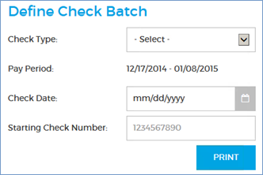

|  |  |
| --- | --- |
| **Check Type** | The type of checks to print. |
| **Pay Period** | The pay period for the Check Type you selected; you cannot change this. |
| **Check Date** | Default date is the current date for Manual checks and 7 days after the end of the Pay Period for all other checks; see the restrictions below.  **For Manual checks**, you cannot set a Check Date earlier than the current date or more than 7 days later than the current date.  **For all other checks**, you cannot set a Check Date earlier than the Pay Period End date or more than 7 days later than the Pay Period End date. |
| **Starting Check Number** | The check number to start the print batch.  **Warning:** Do not change this number unless it's absolutely necessary. |

1. Click **PRINT**.

What happens next:

One of the following print batch summary reports is generated as a PDF file that you may open, save, or cancel using the buttons at the bottom-right of your browser:



*Termination Payroll Summary* – opens if the check type is "Termination"

*Allotment Check Register* – opens if the check type is "Allotment"

*Check Register* – opens if the check type is "Manual," "Bonus," or "Regular." If you are printing a batch of Manual checks, this report includes any previous Manual check print batches for the current date.

The checks appear in the Check Register with a status of "Open Not Cashed."

Manual checks are removed from the Manual Checks table.

The batch is saved to an EZPaySuite "Checkbook" with a status of "Pending." To continue processing the batch, log onto EZPaySuite.

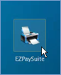

Follow the instructions in the *EZPaySuite User Guide*, which is located on the JCDC Share drive at S:\ACOM\Documentation\ EZPaySuite_UserGuide_v860.pdf.

**Note:** If you have specified a check batch for which there is no data (for example, it has already been printed or payroll has not been finalized yet), an error message will display stating that there is nothing in the queue.

## Printing reissued checks

Use these steps to print checks that have been approved for reissue.

1. Click **Reissues** on the main menu.



**Optional:**

To fetch a specific check or range of checks, filter the results (page 50).

1. Click **PRINT BATCH** at the upper-right of the table.

C:\Users\MALTES~1.JOA\AppData\Local\Temp\1\SNAGHTML8dde551b.PNG

What happens next:

The *Reissued Checks Print List* report is generated as a PDF file that you may open, save, or cancel using the buttons at the bottom-right of your browser. This report includes any previous Reissued check print batches for the current date.



The checks are removed from the Reissues tab and appear in the Check Register with new check numbers and a status of "Open Not Cashed." The original checks remain in the Check Register with a status of "Reissued."

The batch is saved to an EZPaySuite "Checkbook" with a status of "Pending." To continue processing the batch, log onto EZPaySuite.



Follow the instructions in the *EZPaySuite User Guide*, which is located on the JCDC Share drive at S:\ACOM\Documentation\ EZPaySuite_UserGuide_v860.pdf.

**Note:** If you have specified a check batch for which there is no data (for example, it has already been printed or payroll has not been finalized yet), an error message will display stating that there is nothing in the queue.

### Removing reissued checks from the print queue

Use these steps to remove Reissued checks from the print queue.

You must have a SAAS user role of **Super User** or **Approver** to perform this task.

1. Click **Reissues** on the main menu.



**Optional:** To fetch a specific check or range of checks, see Searching the Reissues tab, below.

1. Click the **remove** button in the far-right column for each check you want to remove. This reverts the check to its previous status, i.e. "Stopped" or "Returned."



### Searching the Reissues tab

Use these steps to filter or search the Reissues tab for specific checks or ranges of checks.

**Note:** There are two filter buttons. One is **Filter** and the other is **FILTER** (uppercase). The **Filter** button toggles (closes and reopens) the filter display without changing any of your filter settings, while the **FILTER** button reloads the Reissues tab with your filters applied.



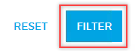

1. Click **Reissues** on the main menu.



1. Click **Filter** at the far right of the page.



1. Enter criteria in any of the search fields.



|  |  |
| --- | --- |
| **Original Check Number** | Enter a seven-digit number for the check. |
| **Student ID** | Enter a seven-digit number. |
| **SSN** | Enter a student's complete SSN. |
| **Payee** | Enter any part of the payee's name. For instance, if you enter "ste," you will fetch such names as Stella Jones, Esteban Garcia, Anne Stevens, Jane Austen, and Jesus Beneste. |
| **Type** | Select a check type from the drop-down: Allotment, Bonus, Manual, Regular, or Termination. |
| **Amount** | Type the decimal point if you want to include the cents amount. Examples:  **100** = one hundred dollars  **100.00** = one hundred dollars  **100.34** = one hundred dollars and thirty-four cents  **.34** = thirty-four cents |

* Clicking the **Filter** button at any time toggles (closes or reopens) the filter display, leaving all your selections.



1. Click **FILTER** to reload the Reissues page with the filtered results. **RESET** clears all the filters and leaves the Reissues display unchanged.



**Notes:** **1** – If all the filters are empty and you click the **FILTER** button, the entire Reissues tab will display.  
  
**2** – If you click off the Reissues tab to another tab, all your filters will be cleared, and the entire Reissues tab will display when you return.

## Reprinting a single check

A check's Status must be "Open Not Cashed" to be reprinted. Use these steps to reprint a check.

1. Click **Check Register** on the main menu.



**Optional**: To fetch a specific check or range of checks, filter the results (page 55).

1. Click the **Reprint** **Check** button in the Actions column for the check you want to reprint.

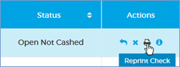

1. 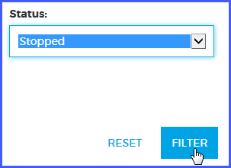Review the information in the Reprint Check form. The **Admin ID** is your ID.

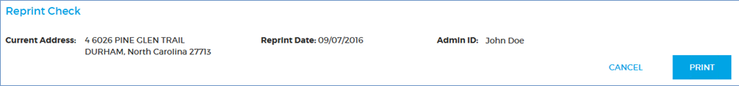

1. Click **PRINT**. **CANCEL** closes the form and takes no action.

The check file is saved to EZPaySuite with a status of "Pending." To continue processing the check, log onto EZPaySuite.



Follow the instructions in the *EZPaySuite User Guide*, which is located on the JCDC Share drive at S:\ACOM\Documentation\ EZPaySuite_UserGuide_v860.pdf.

## Reprinting multiple checks

A check's Status must be "Open Not Cashed" to be reprinted. Use these steps to reprint multiple checks.

1. Click **Check Register** on the main menu.



**Optional**: To fetch a specific check or range of checks, filter the results (page 55).

1. Click the checkboxes at the far left of the Check Register to select the checks you want to reprint.

**Tip:** To select all the checks on the page, click the box at the top of the Check Register.  
  
Click the box again to deselect all the checks.

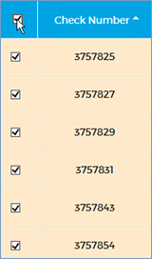

1. Click the **Reprint** **Check** button in the Actions column for *any* selected check.



1. Review the information in the Reprint Check dialog.

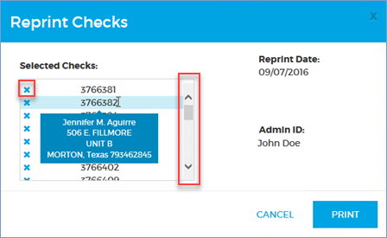

The **Admin ID** is your ID.

Use the scrollbar if necessary to see all the Selected Checks.

Hover over a check number to see the payee and the address the check will be mailed to.

**Optional:** click the **remove** button next to any check to remove it from the queue.

1. Click **PRINT**. **CANCEL** closes the form and takes no action.

The batch is saved to an EZPaySuite "Checkbook" with a status of "Pending." To continue processing the batch, log onto EZPaySuite.



Follow the instructions in the *EZPaySuite User Guide*, which is located on the JCDC Share drive at S:\ACOM\Documentation\ EZPaySuite_UserGuide_v860.pdf.